**Cylinder and Sphere Sensor (no javascript)**

Tests for the Cylinder and Sphere Sensor, controlling itself or another object. None of these demo’s have JavaScript capabilities.

**cylSensor_basic.x3d**

Single Cylinder that can be scrolled left and right.

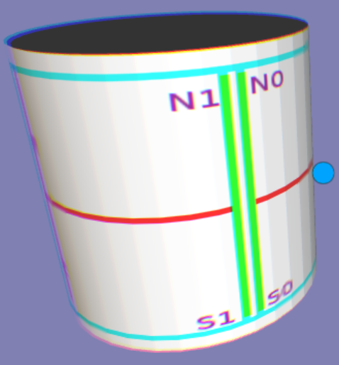

**cylSensor_dial.x3d**

The Cylinder is rotated 90 degrees around the X-axis and can be used as a dial, like a dimmer switch.

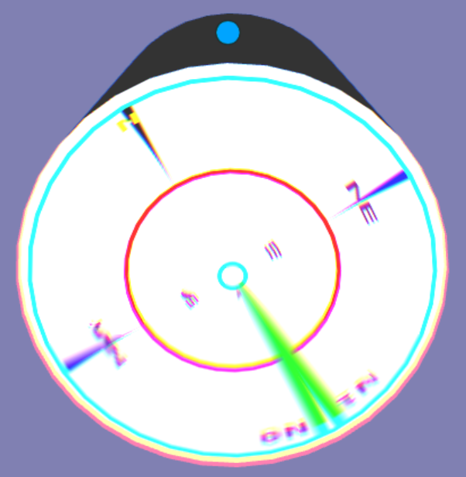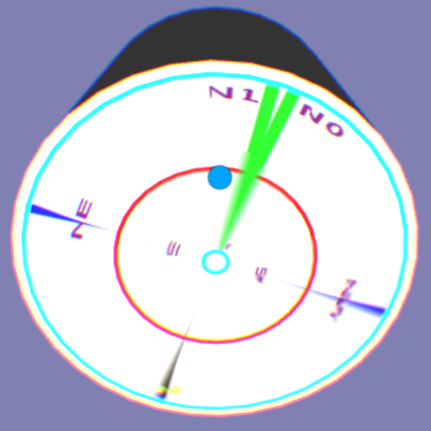

**cylSensor_ObjControlsAnother.x3d**

Dragging the lower right Cylinder controls the rotation of the upper left Cylinder textured with the dog.

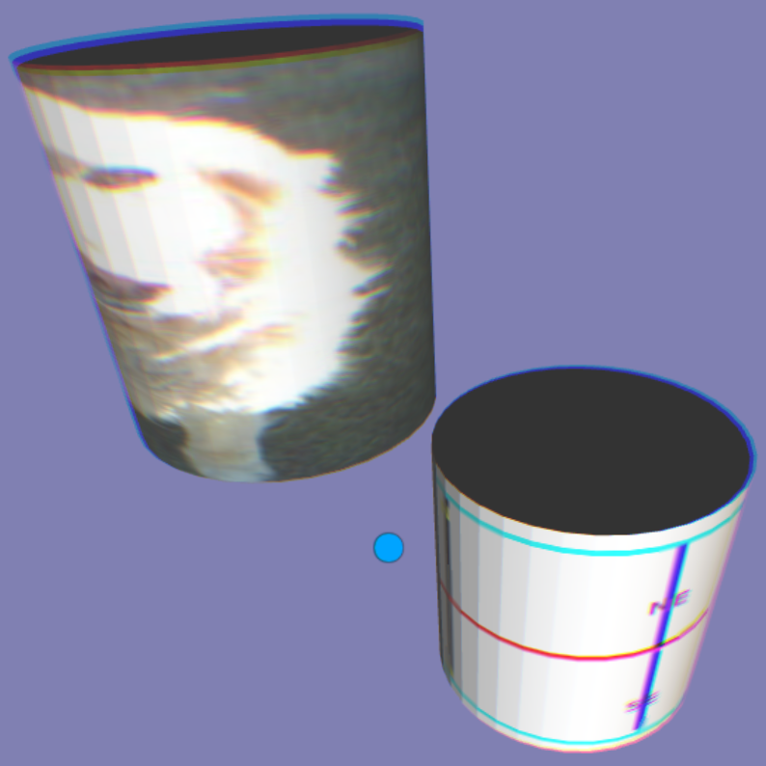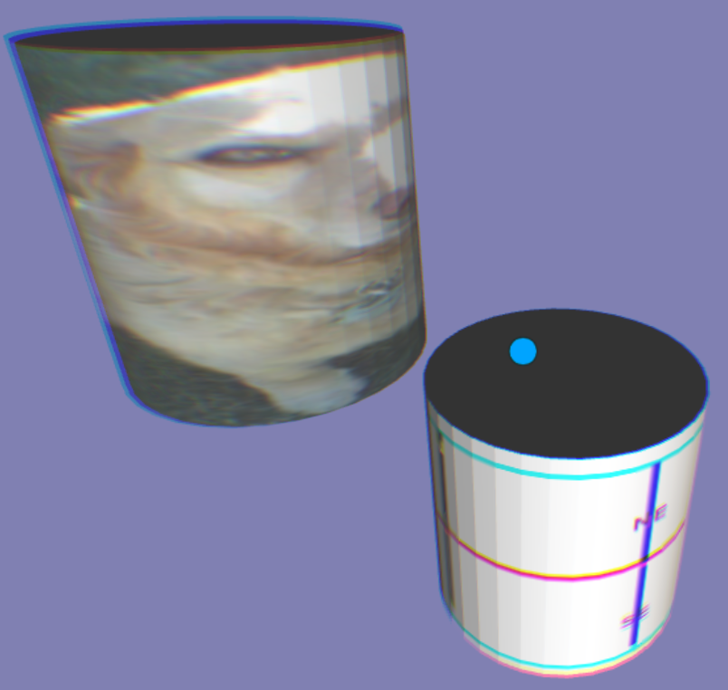

**SphereSensor_basic.x3d**

Similar to Google Earth, dragging the sphere will rotate the ‘Earth’ sphere to another location.

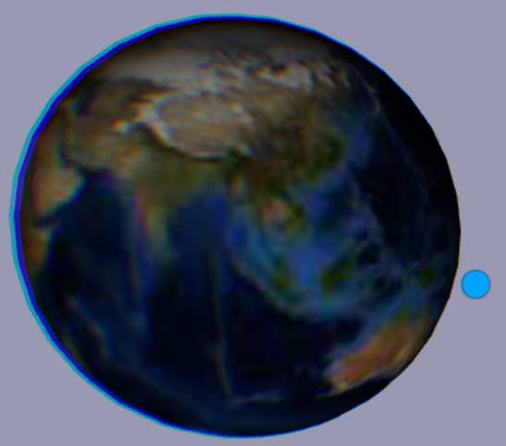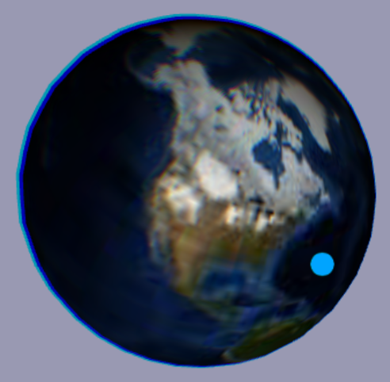

**SphereSensor_twoObjects.x3d**

Two independent Sphere Sensors. The first scene is the initial view and both Sphere are dragged and rotated in the second scene.

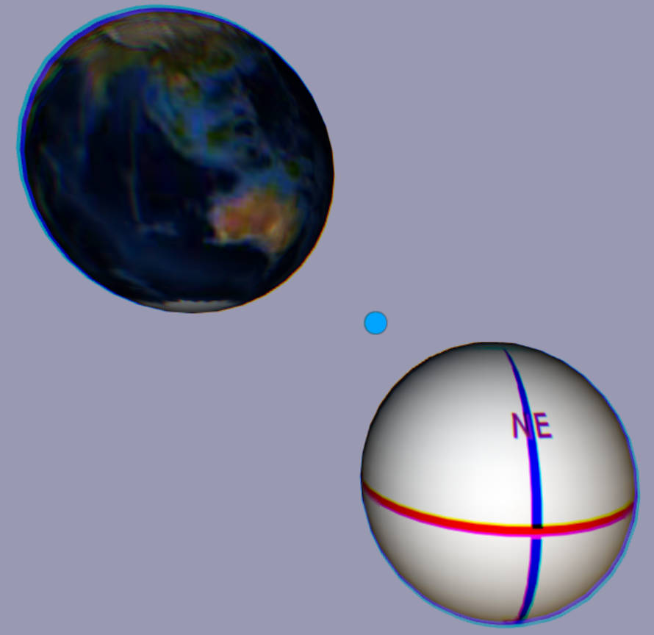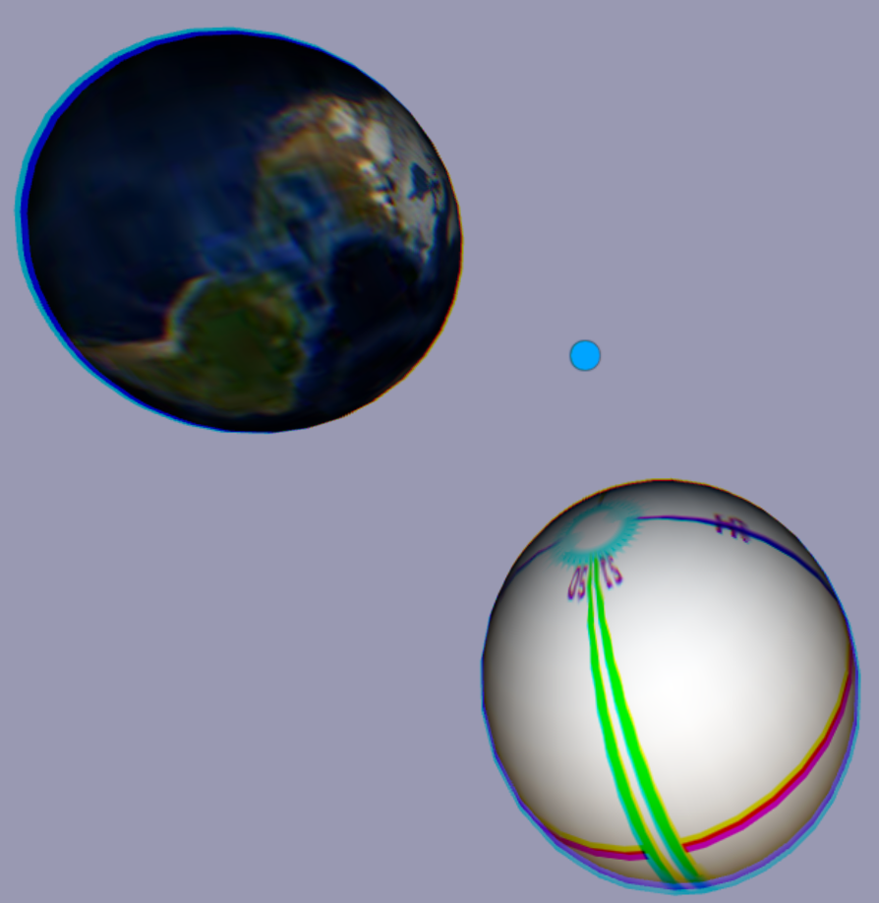

**SphereSensor_ObjControlsAnother.x3d**

Dragging the bottom sphere will control the rotation of the above sphere.

